**Final Project: Digital Transformation Strategy for a Mid-sized Retail Chain**

Instructions: Use this template to draft the project deliverables. You may modify the template to include more information.

**Step I: Current system assessment**

1. **System architecture overview**

The retailer's current technology infrastructure is fragmented and heavily reliant on legacy systems:

* **POS System**: Windows CE-based terminals with outdated card reader drivers. Transactions take more than 5 seconds, causing slow checkouts.
* **E-commerce**: Magento 1.9 on a standalone MySQL database. Poor performance metrics include cumulative layout shifts over 0.25 and slow page loads on mobile networks.
* **Data Storage**: On-premise SQL databases per store. Nightly batch updates result in inconsistent and delayed data synchronization with headquarters.
* **Inventory Management**: Manually maintained through Excel spreadsheets. This leads to inefficient restocking and frequent stockouts.

1. **Pain-points matrix**

|  |  |  |
| --- | --- | --- |
| **Pain point** | **Impact** | **Root cause** |
| Checkout delays | Reduced conversion rates | Slow POS processing on Windows CE |
| Restocking inefficiency | Stockouts and delayed orders | Manual inventory via spreadsheets |
| Fragmented customer data | Ineffective marketing, poor personalization | Disconnected data sources across e-commerce and stores |

**3. Key inefficiencies**

The architecture's dependence on manual and legacy systems hinders agility and scalability. Key inefficiencies include:

* Manual data entry and batch updates create operational bottlenecks.
* Lack of integration across e-commerce and store systems causes data silos.
* Real-time visibility into inventory is absent, limiting omnichannel capabilities.
* System sluggishness directly affects user experience and sales.

**Step II: Stakeholder requirements**

1. **Stakeholder identification**

|  |  |
| --- | --- |
| **Stakeholder** | **Interests** |
| Customers | Fast purchases, unified cart, real-time stock visibility |
| Store staff | Reliable, fast POS; inventory lookup across channels |
| Management | Unified customer view; real-time analytics; profitability insights |
| IT Team | Scalable, secure, API-first infrastructure; GDPR compliance |

**2. Requirements**

**Functional requirements:**

|  |  |  |
| --- | --- | --- |
| **ID** | **Requirement** | **Justification** |
| FR01 | Process in-store sales in ≤5s | Addresses checkout delays for customers and staff |
| FR02 | Real-time inventory decrement | Prevents stockouts, supports omnichannel operations |
| FR03 | 360° customer profile via API | Enables personalized marketing and supports management analytics |
| FR04 | Support Buy Online Pickup In-Store (BOPIS) | Meets modern customer expectations and expands sales channels |

**Non-functional requirements:**

|  |  |  |
| --- | --- | --- |
| **ID** | **Requirement** | **Justification** |
| NFR01 | System availability ≥ 99.9% | Ensures reliable operations for all stakeholders |
| NFR02 | Page load time < 2 seconds on 4G | Enhances customer experience and retention on mobile platforms |
| NFR03 | Scalability to 3x holiday traffic | Accommodates future growth and peak demand without degradation in performance |
|  |  |  |

**Step III: Alternative solution evaluation**

1. **Comparative analysis**

Compare three proposed solutions based on the evaluation criteria: Functional fit (40%), scalability (20%), total cost of ownership (20%), implementation risk (10%), vendor viability (10%).

|  |  |  |  |  |
| --- | --- | --- | --- | --- |
| Criteria | Weight | Salesforce Commerce Cloud + POS | Shopify Plus + Square POS | Custom Microservices |
| Functional fit | 40% | 9 × 0.4 = 3.6 | 8 × 0.4 = 3.2 | 9 × 0.4 = 3.6 |
| Scalability | 20% | 10 × 0.2 = 2.0 | 7 × 0.2 = 1.4 | 10 × 0.2 = 2.0 |
| Cost (Year 1) | 20% | $150,000 → 6/10 × 0.2 = 1.2 | $50,000 → 10/10 × 0.2 = 2.0 | $300,000 → 3/10 × 0.2 = 0.6 |
| Implementation risk | 10% | Score 15 → 6/10 × 0.1 = 0.6 | Score 10 → 9/10 × 0.1 = 0.9 | Score 25 → 3/10 × 0.1 = 0.3 |
| Vendor viability | 10% | 10 × 0.1 = 1.0 | 9 × 0.1 = 0.9 | 7 × 0.1 = 0.7 |
| Total score | 100% | **8.4** | **8.4** | **7.2** |

1. **Recommended solution**

**Shopify Plus + Square POS**

This solution is recommended based on its **low cost**, **fastest time to value**, and **balanced functionality** for the retailer’s needs. While Salesforce offers superior scalability, the incremental benefit does not outweigh the significantly higher cost and longer deployment time for this phase of growth.

**Justification:**

* **Meets key stakeholder needs** like fast checkout, real-time inventory, and unified customer views through integrations and apps.
* **Aligns with business goal** to roll out within nine months due to low implementation time and existing ecosystem support.
* **Provides flexibility** for omnichannel commerce and supports growth up to ~100 stores before needing a more robust backend shift.

1. **Trade-offs**

| **Aspect** | **Advantage** | **Trade-off** |
| --- | --- | --- |
| **Cost** | Lowest TCO at $50,000 in Year 1 | May require re-platforming if scaling past 100 stores |
| **Implementation Speed** | Fast deployment (~3 months) | Some custom integrations may be limited |
| **Scalability** | Good for short-medium term growth | Less scalable than Salesforce or custom options |
| **Customizability** | Strong app ecosystem via Shopify app store | Not as flexible as custom microservices |

**Step IV: Feasibility and risk analysis**

Feasibility Analysis

Technical Feasibility:

The recommended solution—Shopify Plus + Square POS—is cloud-native and designed for rapid integration via REST APIs. It minimizes on-premises infrastructure and aligns well with the IT team's preference for API-first architecture. It is compatible with existing mobile devices and easily connects to marketing, CRM, and inventory platforms.

Economic Feasibility:

Shopify Plus has the lowest Year 1 cost at $50,000, with a positive Net Present Value (NPV) within the first five years. This makes it a financially sound option, especially compared to custom microservices, which only break even after four years. The low upfront investment supports the retailer’s need for quick ROI.

Operational Feasibility:

The platform is designed for ease of use and requires minimal retraining, with most staff able to onboard in under eight weeks. The implementation timeline aligns with the retailer’s nine-month seasonal sales cycle, ensuring system readiness for peak demand periods.

**Risk analysis**

|  |  |  |  |  |
| --- | --- | --- | --- | --- |
| **Risk** | **Probability** | **Impact** | **Risk score** | **Mitigation** |
| Data migration loss | 3 | 4 | 12 | Two dry runs, checksum validation |
| Vendor Outage | 2 | 5 | 10 | |  | | --- | |  |  |  | | --- | | SLA-backed 99.9% uptime; rollback plan with offline POS mode | |

1. **Mitigation effectiveness**

The risk mitigations are **proactive and robust**, supporting the overall implementation timeline:

* **Data migration dry runs** allow early detection of issues and ensure smooth transition without data loss or customer impact.
* **Vendor outage strategies**, such as offline transaction support and SLA enforcement, reduce downtime risk and ensure business continuity.

These controls support the project’s success within the **nine-month timeframe**, meeting both technical and operational readiness.

**Step V: Visualizations and recommendations**

1. **Results and visualizations**

The Shopify Plus + Square POS solution directly addresses all major pain points:

| **Pain Point** | **Resolution** |
| --- | --- |
| **Slow Checkout** | Square POS processes transactions in ≤5 seconds, meeting speed expectations |
| **Stockouts / Manual Inventory** | Shopify provides real-time inventory updates across channels |
| **Fragmented Customer Data** | Unified customer profiles via APIs and integrations into CRM and analytics tools |

**Visual artefact**

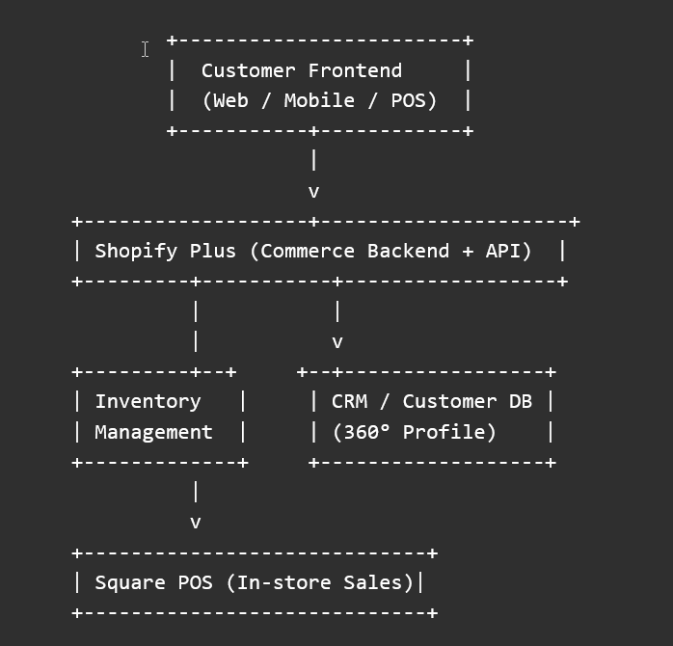

1. **Implementation roadmap**

Key milestones for implementation within nine months

| **Milestone** | **Timeline** | **Description** |
| --- | --- | --- |
| **Project Kickoff** | Month 1 | Finalize vendors, assign teams, and set up environments |
| **Data Cleansing & Migration Prep** | Month 1 – 2 | Audit existing data, prepare mapping for products and customers |
| **POS Hardware Upgrade** | Month 2 – 3 | Replace outdated CE terminals with Square-compatible devices |
| **Shopify Customization** | Month 2 – 4 | Configure themes, product taxonomy, and install key integrations |
| **Inventory System Sync** | Month 4 – 5 | Enable real-time inventory updates and test across stores |
| **Customer Data Integration** | Month 5 – 6 | Sync customer data into CRM; test 360° profile visibility |
| **Training & UAT** | Month 7 | Train staff on POS and admin interfaces; perform user acceptance testing |
| **Soft Launch / Pilot Store** | Month 8 | Launch in pilot stores to test performance and gather feedback |
| **Full Rollout** | Month 9 | Expand deployment chain-wide in time for seasonal sales |